## **TEST D – Graphing**

##### Test Overview

The graphing for this project is an immensely important visual tool for users to view for their understanding and education. The graph is present in the Student Development Tool, Student Self-Assessment Tool and the Quiz tool.

Via visual inspection we must ensure that the graph plot lines correspond to the selected ligands within the ligand table visually with colour coded lines rather than a legend. It is also vital to check that the graph is plotted correctly, via unit testing to ensure that values are calculated accurately within our application. We will then again cross reference the graph to ensure the plot lines correspond to the correct calculated values.

We will also test that the graph with dynamically update with new data when any modifications are made to the receptor and ligand tables (as values for the graph are taken from the data in the tables).

There will be a few buttons (in the Student Self-Assessment Tool) beside to the graph that allow the user to view the answer and reset the graph. We must ensure that they are also working correctly.

##### Test Specification

|  |  |  |
| --- | --- | --- |
| **id** | **Method Tested** | **Condition for Satisfaction** |
| **D1** | Graph color coding | Plot line color corresponds to color in ligand table for that ligand |
| **D2** | Graph calculating | Calculated binding % points correspond to asserted values with mathematical formula |
| **D3** | Plot lines | Plot lines are correct, cross referenced with provided graphs |
| **D4** | Dynamic updating | Graph dynamically updated with data is modified |
| **D5** | Buttons | To reset the graph (self-assessment tool) |

##### Test Description

|  |  |  |  |  |
| --- | --- | --- | --- | --- |
| **id** | **Means of Control** | **Data** | | **Procedures** |
| Input | Output |
| **D1** | Manual | Ligand color | Plot line color | Select ligands to be graphed, manually inspect plot line color to see if match |
| **D2** | Automatic | Receptor subtype, density, ligand | Binding % | Unit test, assert values for binding % for multiple trials of different combinations |
| **D3** | Manual | Binding % | Plot line | View graph plotted corresponds to the binding % |
| **D4** | Manual | Modify data | Graph updates | Modify data in both receptor and ligand table, ensure graph dynamically updates |
| **D5** | Manual | Click buttons | Event occurs | Click all the buttons, ensure they work |

##### Test Analysis Report

Currently unavailable as testing has not yet commenced. *Target Met* criteria will be marked with either ✔ or ✗.

|  |  |  |  |
| --- | --- | --- | --- |
| **id** | **Performance** | **Data Measures** | **Target Met** |
| **D1** | 100%  12/12 Exact Matches  12 Ligands | Colour in Ligand Table == Curve Colour in Graph | Yes |
| **D2** | Performance not Determined  0 Automated Tests successfully Implemented | Assertion Programming Unsuccessful | N/A |
| **D3** | 100%  60/60 Exact Matches  5 Receptors * 12 Ligands | Binding Table Value == Graph X value  @ 50% Specific Binding Percentage | Yes |
| **D4** | 100%  60/60 Exact Matches  5 Receptors * 12 Ligands | Receptor Table Update -> Graph Table Update  Ligand Table Update -> Graph Table Update | Yes |
| **D5** | 100%  12/12 Desired Functionality  12 Graph Buttons | Graph Button Press -> Desired Outcome | Yes |

**Abbreviations**: For the purposes of concise tabulation, the following abbreviations have been used for the tables:

|  |  |  |  |  |
| --- | --- | --- | --- | --- |
| **Ligands** |  | **Button** |  | **Receptor** |
| **L1** | Atropine | **B1** | Download Plot | **M1** |
| **L2** | Pirenzepine | **B2** | Save & Edit Plot | **M2** |
| **L3** | Methoctramine | **B3** | Zoom Tool | **M3** |
| **L4** | Darifenacin | **B4** | Pan Tool | **M4** |
| **L5** | MT-3 | **B5** | Zoom in | **M5** |
| **L6** | S-Secoverine | **B6** | Zoom out |  |
| **L7** | Solifenacin | **B7** | AutoScale |  |
| **L8** | DAU-5884 | **B8** | Reset Axes |  |
| **L9** | Ligand A | **B9** | Toggle Spike Lines |  |
| **L10** | Ligand B | **B10** | Closest Data |  |
| **L11** | Ligand C | **B11** | Compare Data |  |
| **L12** | Ligand D | **B12** | About Plotly |  |

**D1**: Ligands - Colour in Table vs. Colour in Graph: Match (Yes | No)

|  |  |  |  |  |  |  |  |  |  |  |  |
| --- | --- | --- | --- | --- | --- | --- | --- | --- | --- | --- | --- |
| **L1** | **L2** | **L3** | **L4** | **L5** | **L6** | **L7** | **L8** | **L9** | **L10** | **L11** | **L12** |
| Y | Y | Y | Y | Y | Y | Y | Y | Y | Y | Y | Y |

**D2**: Unit Testing (Software Driven) : Unit testing, in the form of automated assertion testing was planned and attempted but, due to the nature of the graph data, no valid results could be determined. The rigour with which manual testing was performed is enough to ensure correctness and validity.

**D3**: Binding Percentage vs. Plotline: Match (Yes | No)

|  |  |  |  |  |  |  |  |  |  |  |  |  |
| --- | --- | --- | --- | --- | --- | --- | --- | --- | --- | --- | --- | --- |
|  | **L1** | **L2** | **L3** | **L4** | **L5** | **L6** | **L7** | **L8** | **L9** | **L10** | **L11** | **L12** |
| **M1** | Y | Y | Y | Y | Y | Y | Y | Y | Y | Y | Y | Y |
| **M2** | Y | Y | Y | Y | Y | Y | Y | Y | Y | Y | Y | Y |
| **M3** | Y | Y | Y | Y | Y | Y | Y | Y | Y | Y | Y | Y |
| **M4** | Y | Y | Y | Y | Y | Y | Y | Y | Y | Y | Y | Y |
| **M5** | Y | Y | Y | Y | Y | Y | Y | Y | Y | Y | Y | Y |

**D4**: Ligand or Receptor Update vs Graph Update (Yes | No)

|  |  |  |  |  |  |  |  |  |  |  |  |  |
| --- | --- | --- | --- | --- | --- | --- | --- | --- | --- | --- | --- | --- |
|  | **L1** | **L2** | **L3** | **L4** | **L5** | **L6** | **L7** | **L8** | **L9** | **L10** | **L11** | **L12** |
| **M1** | Y | Y | Y | Y | Y | Y | Y | Y | Y | Y | Y | Y |
| **M2** | Y | Y | Y | Y | Y | Y | Y | Y | Y | Y | Y | Y |
| **M3** | Y | Y | Y | Y | Y | Y | Y | Y | Y | Y | Y | Y |
| **M4** | Y | Y | Y | Y | Y | Y | Y | Y | Y | Y | Y | Y |
| **M5** | Y | Y | Y | Y | Y | Y | Y | Y | Y | Y | Y | Y |

**D5**: Graphing Buttons Functionality vs Intended Functionality Match (Yes | No)

|  |  |  |  |  |  |  |  |  |  |  |  |
| --- | --- | --- | --- | --- | --- | --- | --- | --- | --- | --- | --- |
| **B1** | **B2** | **B3** | **B4** | **B5** | **B6** | **B7** | **B8** | **B9** | **B10** | **B11** | **B12** |
| Y | Y | Y | Y | Y | Y | Y | Y | Y | Y | Y | Y |

**Appendices**

1. Colour Matching Samples

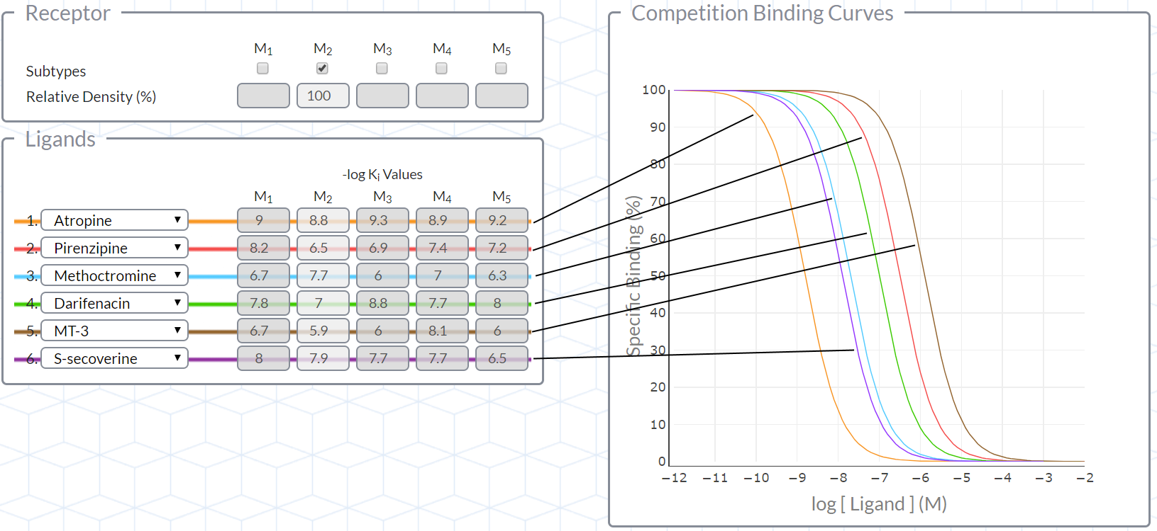

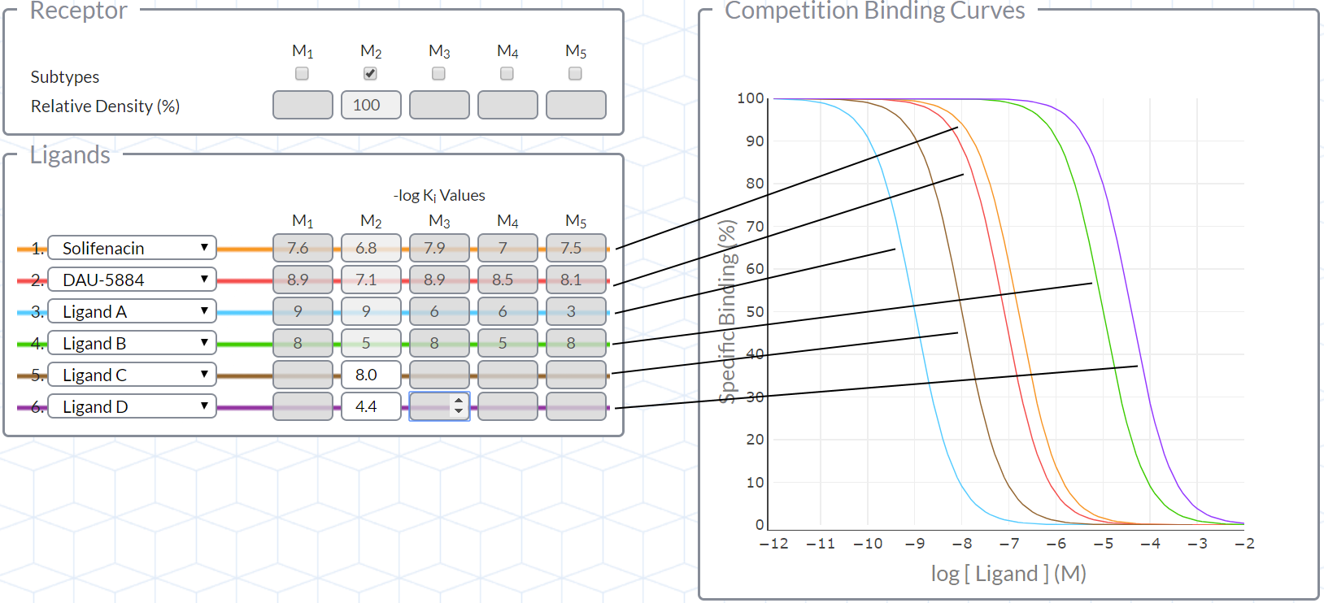

1. Ligand Binding Samples

